Project Design Phase-**||**

**Technical Architecture**

|  |  |
| --- | --- |
| TEAM LEAD | RUBA A |
| NM ID | 2528AD5D5FF8201AD214F41476392A40 |
| PROJECT NAME | How to submit your website’s sitemap to Google Search Console |

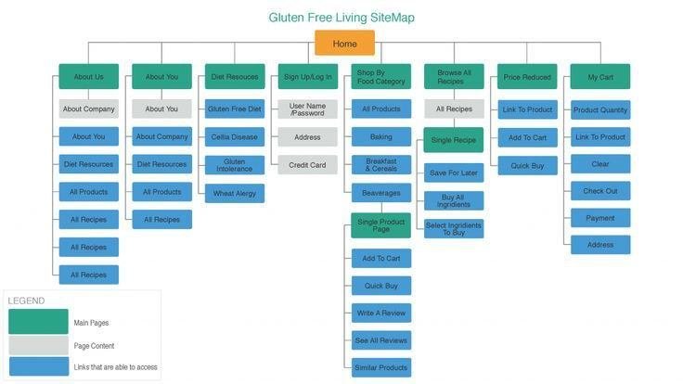

Submitting your website's sitemap to Google Search Console involves a straightforward technical process. Here's a high-level technical architecture for accomplishing this task:

**1.Web Server:**

Your website's sitemap should be hosted on your web server. Ensure that the sitemap file is accessible through a URL, such as "https://www.yourwebsite.com/sitemap.xml."

**2.Verification File**:

To verify ownership of your website in Google Search Console, you'll need to create a verification file provided by Google.

**3.Web Server Configuration:**

Place the verification file in your web server's root directory or at the specified location based on Google's instructions. This file is crucial for confirming your website's ownership.

**4.Google Search Console Account:**

Ensure you have a Google Search Console account. If you don't have one, you'll need to create it.

**5.Verification Process:**

Access Google Search Console and select your website property.

**6.Access Sitemaps Section:**

In the Search Console dashboard, navigate to the "Sitemaps" section. This is where you can submit your sitemap.

**7.Add/Test Sitemap:**

Click the "Add/Test Sitemap" button within the Sitemaps section.

**8.Enter Sitemap URL:**

In the dialog box that appears, enter the URL of your sitemap, such as "https://www.yourwebsite.com/sitemap.xml."

**9.Submit Sitemap:**

Click the "Submit" button to initiate the submission of your sitemap.

**10.Verification Process:**

Google will access the verification file on your web server to confirm your ownership. Once verified, the sitemap submission process is complete.

**11.Monitoring:**

After submission, you can monitor the status of your sitemap in the Sitemaps section of Google Search Console. It will show whether there are any errors or issues with your sitemap.

**12.Resubmission:**

Whenever you make significant changes to your website or update the sitemap, it's a good practice to resubmit the sitemap to ensure Google has the latest information.

The technical architecture for submitting your website's sitemap to Google Search Console primarily involves hosting the sitemap file on your web server and utilizing Google's verification process. Once verified, you can easily submit and monitor your sitemap through the Google Search Console interface. This process helps Google index your website's content effectively.